Session 4

1.Given the daily order counts for a Swiggy delivery partner over 10 days: [12, 15, 17, 14, 13, 16, 200, 18, 14, 15], plot a simple graph (hand-drawn or using any tool) and describe whether the data is left skewed, right skewed, or symmetrical. Explain your reasoning based on the shape.
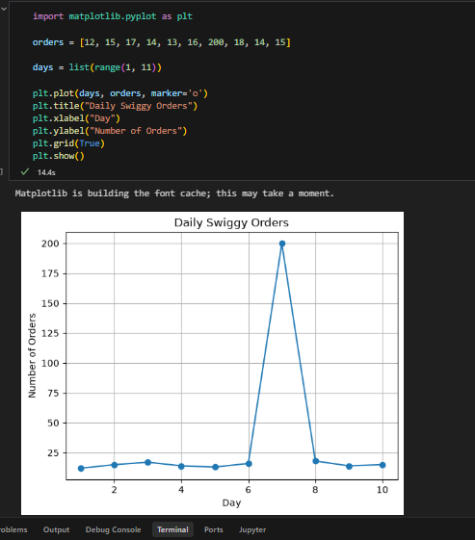

The data is right-skewed (positively skewed) because one value (200) is much larger than the others. This large value pulls the graph to the right.
2.Take the following list of Instagram influencer follower counts (in thousands): [5, 7, 8, 8, 9, 10, 12, 15, 95]. Calculate the mean and median, then state which is higher and what that tells you about the skewness of the data.<br><br><em><strong>Hint:</strong> If the mean is pulled away from the median, the data is skewed in that direction.</em>
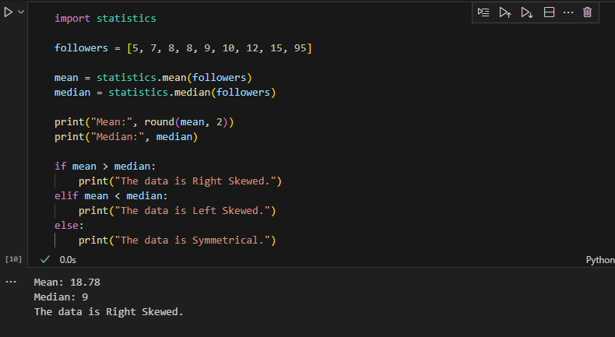

3.Find a real-world example of right-skewed data from any app you use (like Zomato order amounts, Paytm wallet balances, or YouTube video views). Briefly describe the dataset and explain why you think it is right skewed.
[1200, 1500, 1800, 1700, 1600, 21000]
The dataset is right-skewed because one video has 21,000 views, while the others have around 1,200–1,800 views. The very high value increases the mean and creates a long tail on the right.
4. Given this dataset of Flipkart product ratings: [3, 3, 4, 4, 4, 5, 5, 5, 5, 5], draw a rough graph and state if the distribution is symmetrical, left skewed, or right skewed. Justify your answer in one line.
